Gate In Portal Integration

**Synopsis:**

1. Software Requirements.
2. GateIn Portal Extension Build and Deployment.
3. MolplexDrugDiscovery Build and Deployment.
4. Jboss Installation and Deployment.
5. Database configuration with Jboss Server and workspace.
6. How to Use the GateInPortal.
7. Screens Covered in this versions.
8. Added a new Folder registerLink & dashboard Removal

1. **Software Requirements.**

* Java JDK Version Greater than 1.6.0
* apache-maven-3.0.4
* Application Server - GateIn-3.5.0.Final-jbossas7
* DataBase –Mysql 5.2 or greater
* Eclipse Juno

**2. GateIn Portal Extension Build and Deployment**.

The First Step to Bring the GateIn Portal Extension is pull the code from GIT Repository.

Open the Eclipse then go to file 🡪import 🡪maven🡪existing maven project -🡪then select the workspace pulled from git gatein-portal-extension click finish.

After that it will take few minutes to auto build…

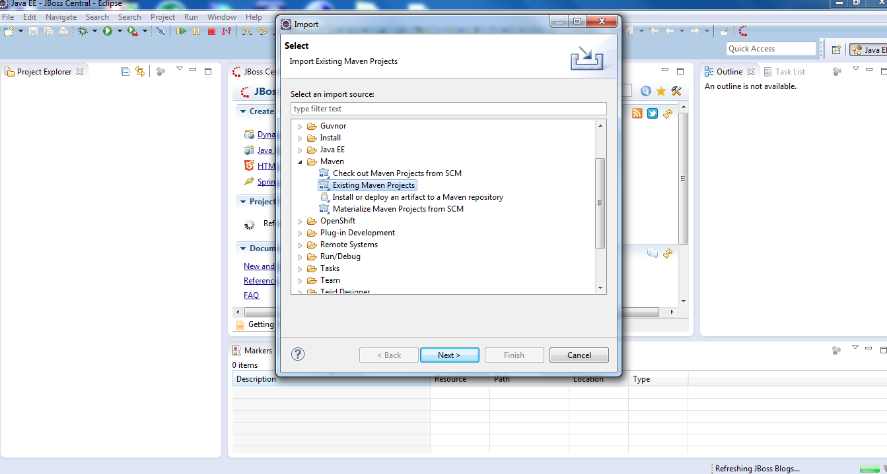

Then

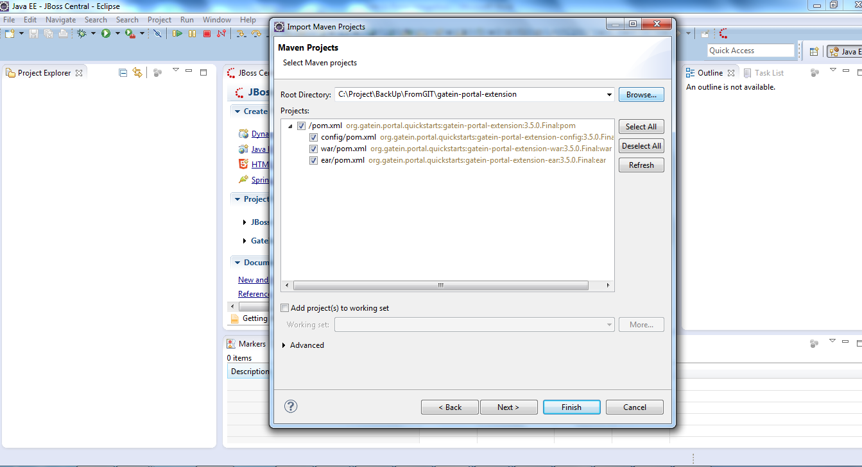

Then once maven import success you need to build the application by right click the root project

gatein-portal-extension -🡪RunAs🡪Maven Build

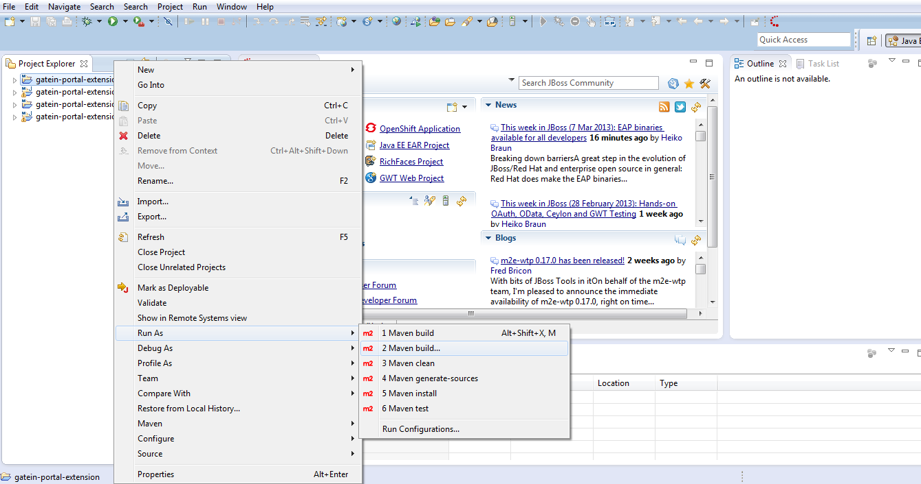

Then enter **clean install** in the Goals section and click Run button it will download all the required Jars and compile the source code.

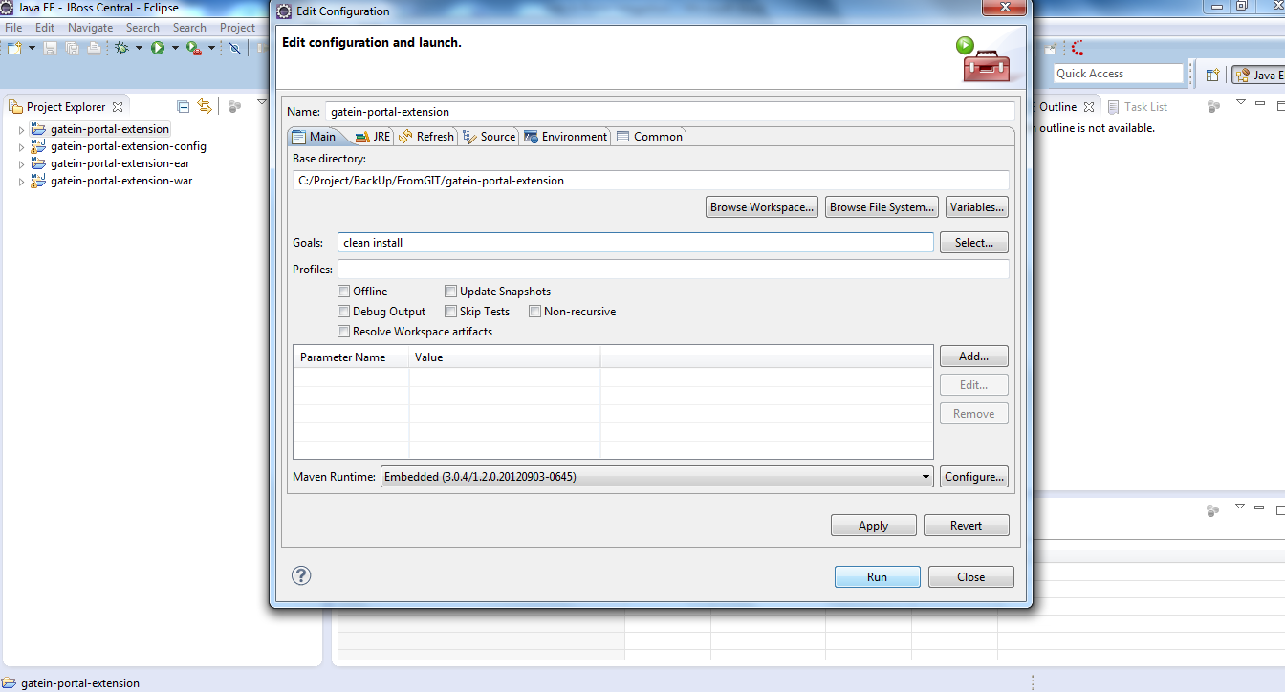

Once Build Success you will get message like in the below Screen

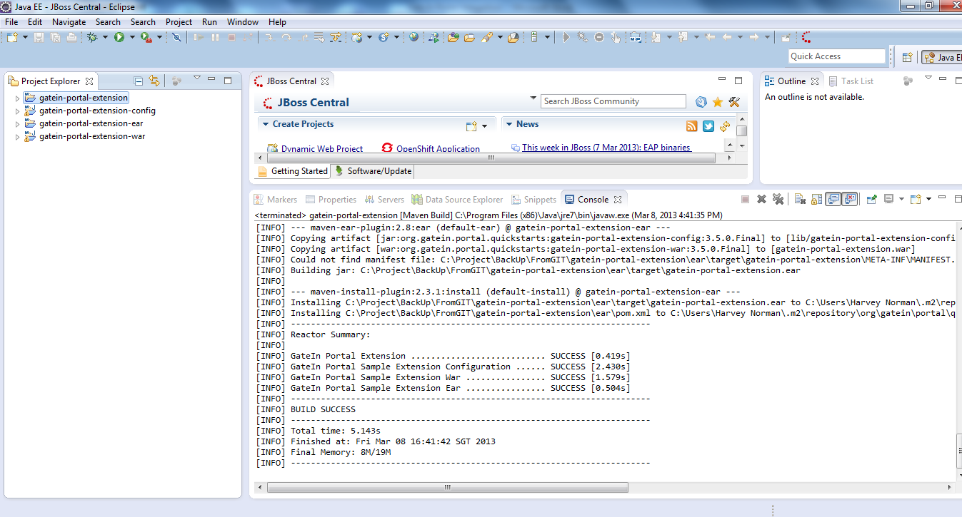

Then refresh the project and go to gatein-portal-extension-ear 🡪 target folder and expand it you will see the gatein-portal-extension.ear file copy the file and paste it in your GateIn Jboss As7/gatein/extension folder.

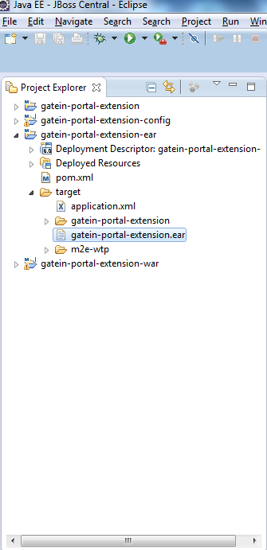

**3.molplexDrugDiscovery Build and Deployment**.

Pull out the latest code from Git using the following command,

Git pull [molplex_git@molplex.com:/opt/git/discovery_portal.git](mailto:molplex_git@molplex.com:/opt/git/discovery_portal.git)

Once you pulled out the code need to import in to eclipse using the above mentioned steps.

File 🡪Import🡪maven🡪Existing Maven Projects

Choose the molplexdrugdiscovery project and click finish.

And follow the same steps as mentioned above finally you will get molplexdrugdiscovery.ear file in the molplexdrugdiscovery-ear/target folder copy the file and paste it in the

\\GateIn-3.5.0.Final-jbossas7\gatein\extensions

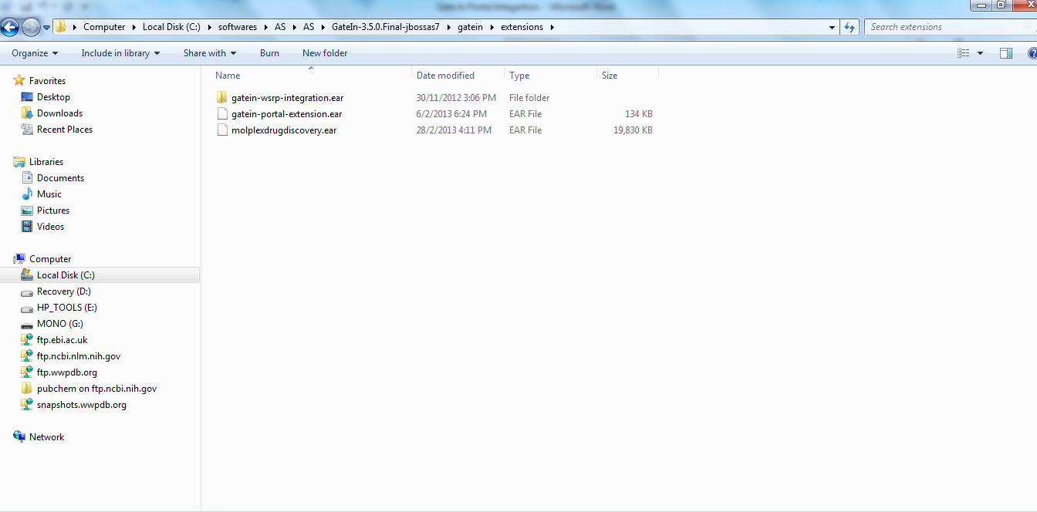

**4.Jboss Installation and Deployment.**

Down load the GateIn-3.5.0.Final-jbossas7.zip version from <http://www.jboss.org/gatein/download>

Extarct the folder it contains the following folder Structure,

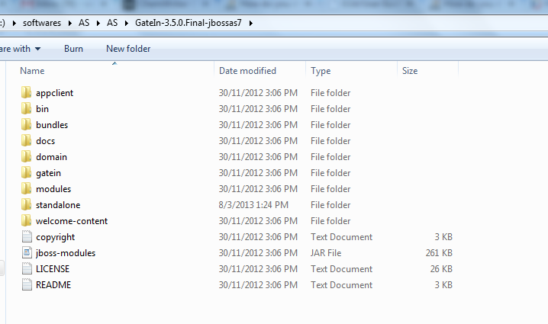

Now the GateIn-3.5.0.Final-jbossas7\gatein\extensions contains gatein-portal-extension.ear

And molplexdrugdiscovery.ear.

**5.Database configuration with Jboss Server and workspace.**

In order to work portal application we need database to store and retrieve the information’s

Molplex database file will be available in molplex .git

You can pull out the file and store it in

C:\Program Files\MySQL\MySQL Server 5.5\bin\molplex_v1.3.sql

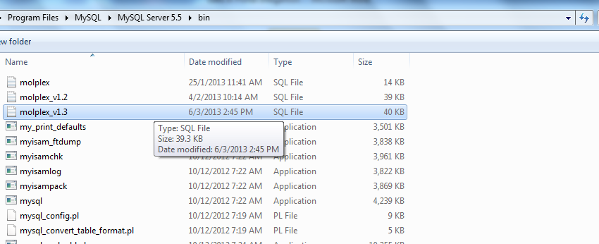

Before restoring the database you need to create the new schema in MySql Server

Now go to command prompt and enter the path

C:\Program Files\MySQL\MySQL Server 5.5\bin

After that execute the following command to restore it in to MySqlServer

**mysql -u root -p -h localhost NewSchemaName < molplex_v1.3**

it will ask password to enter , now enter the MySql Server password now it will take few second to restore the table structures of molplex.

Now we need to connect the database with Application Server,for that we need to create the data source,

Pull out the DataSource folder from molplex.git it contains two things module and standalone.xml

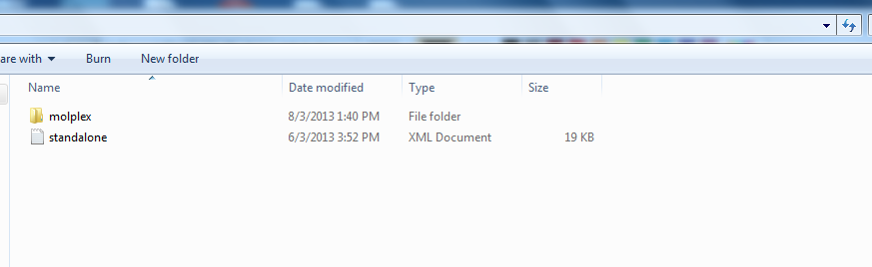

Copy the molplex folder and paste it in you GateInJboss ApplicationServer,

\\GateIn-3.5.0.Final-jbossas7\modules\com it contains the mysql database driver jars.

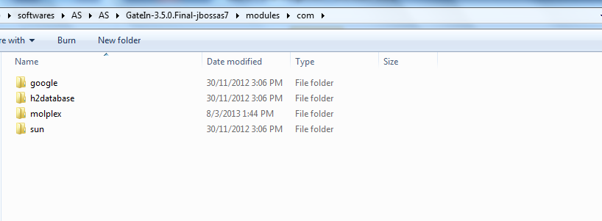

Now copy the standalone.xml and paste it in \GateIn-3.5.0.Final-jbossas7\standalone\configuration\

It will ask to override the file click yes.

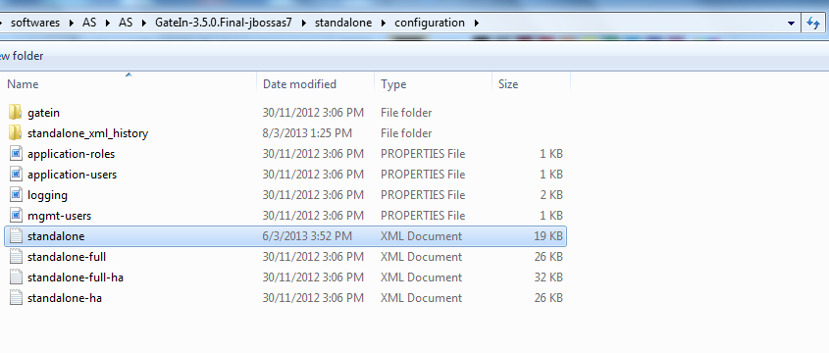

After this Just Edit the standalone.xml and enter the url as localhost and database name which you created in the MySqlServer and also enter the username and password of your MySqlServer.

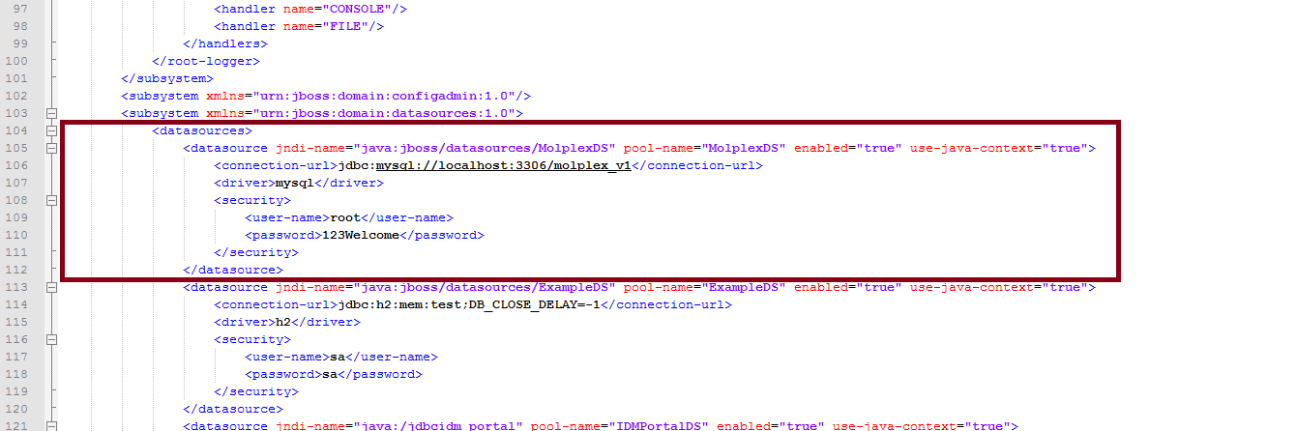

Now Data Source Has been created next thing is we need to tell this data source name to our molplexworkspace.

So now go to your molplexDrugDiscovery workspace in eclipse and press ctrl+Shift+r

Type the file name persistence.xml

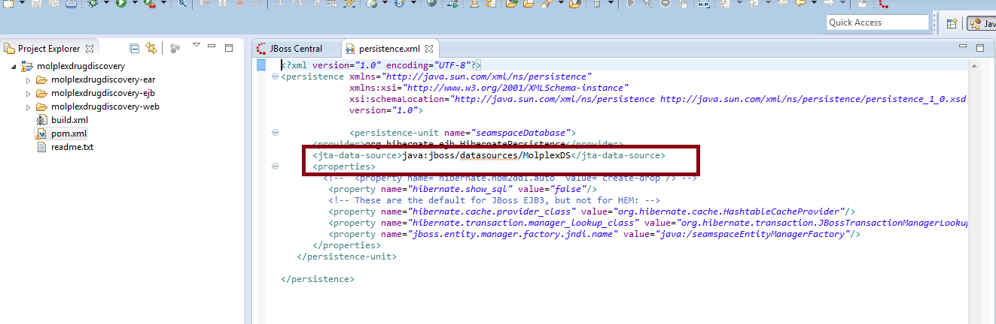

Now data base is connected with application server as well as coding

**Run The Server**

Now go to command line and move to \\GateIn-3.5.0.Final-jbossas7\bin

And run the standalone.bat file for windows and standalone.sh for Linux.

Once the server is up you will get the message available in screen,

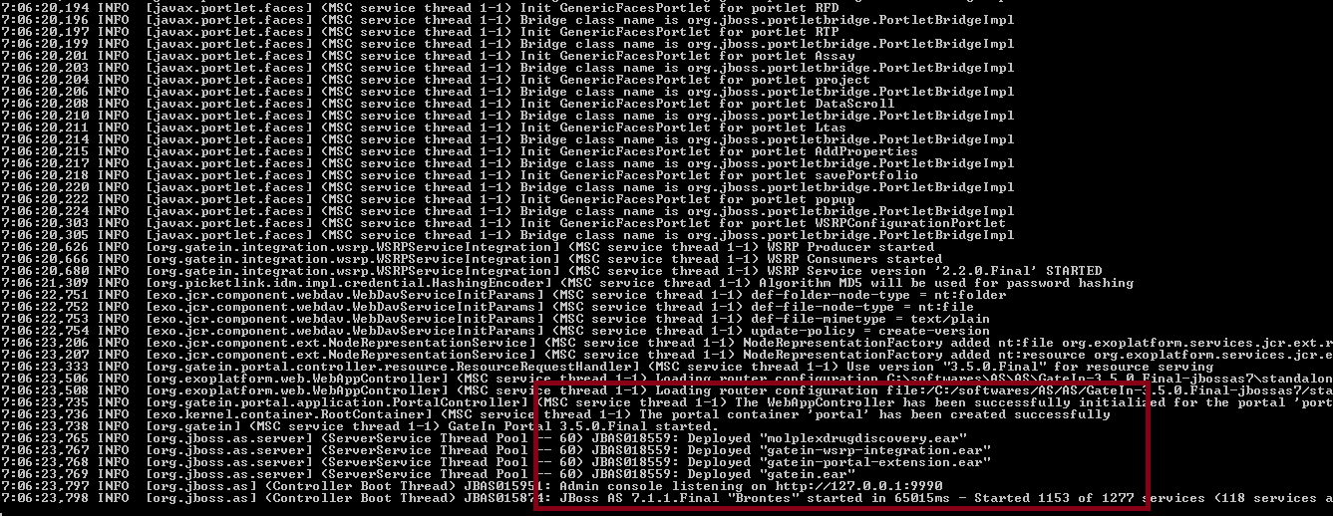

**5.How to Use the GateInPortal.**

Then move on to the browser and type the following URL

<http://localhost:8080/portal>

It will bring the Gate In home page,signin as username : root and password : gtn

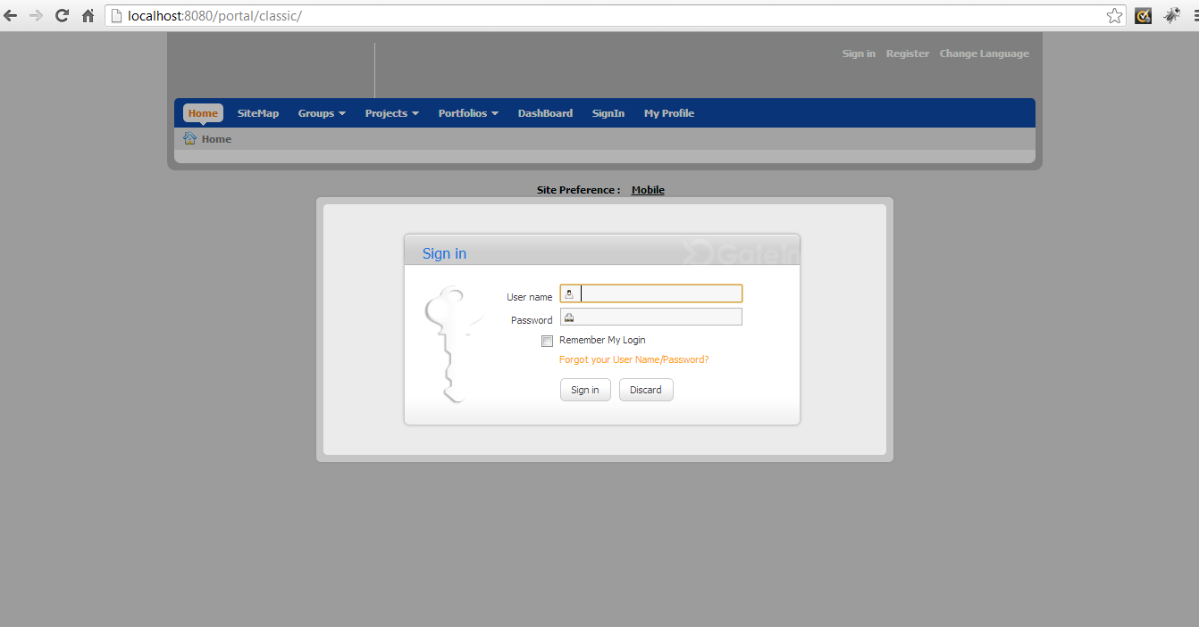

After that go to Group🡪Administartion🡪Site Export/Import,

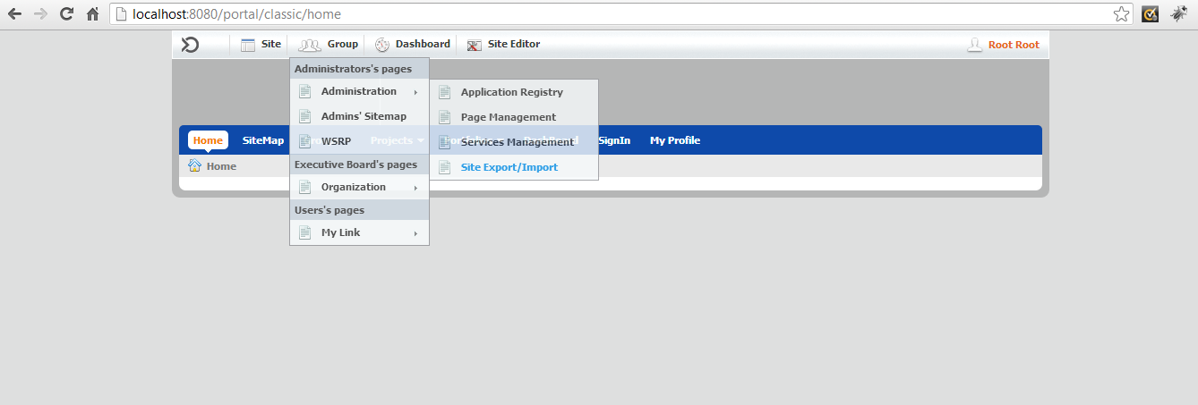

Then click Import Site it will pop up a widow asking you select the file , choose the

**portal_classic_2013-03-04_09-56-45.**zip which is also pulled out from git andstoredin your local diskfile and click import, this will import the layout designs .

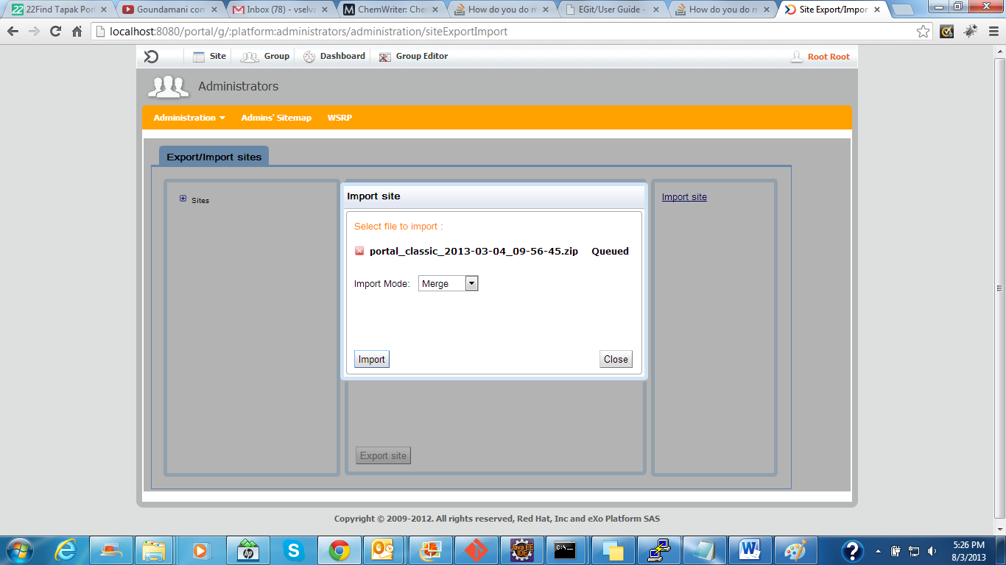

Once import done click close button then go to home page, it will show all the portlets,

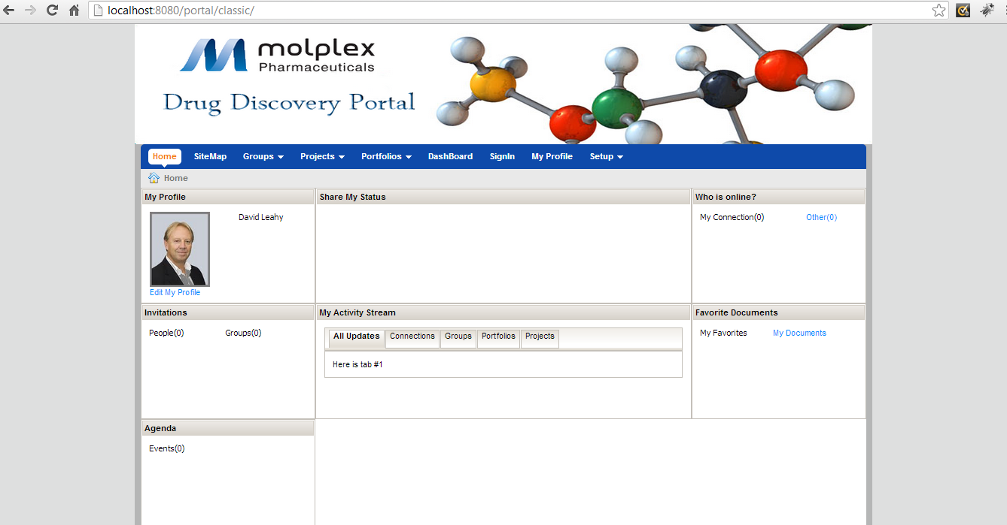

1. **Screens Covered in this versions.**

In this Version we have covered the following Screens ,

1. Add Compound Property
2. Add Assay
3. RTP
4. Assay
5. Add Group
6. Add Portfolio
7. Add Project.

Please see the screen shots

Add Compound Property

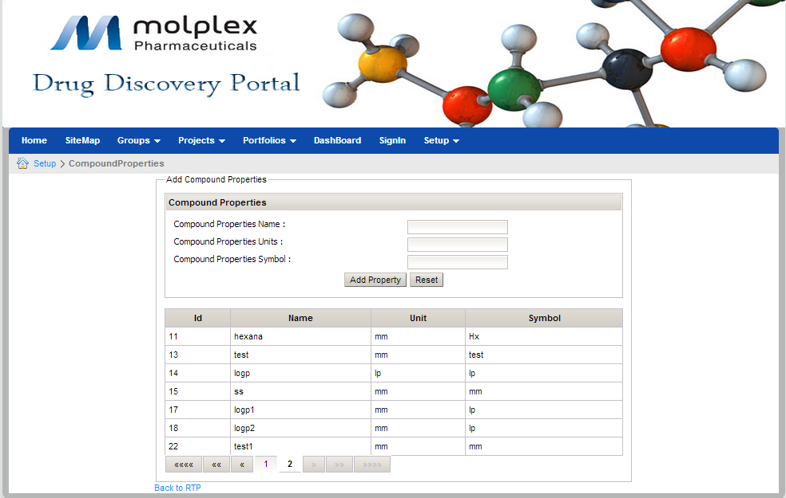

Add Assay

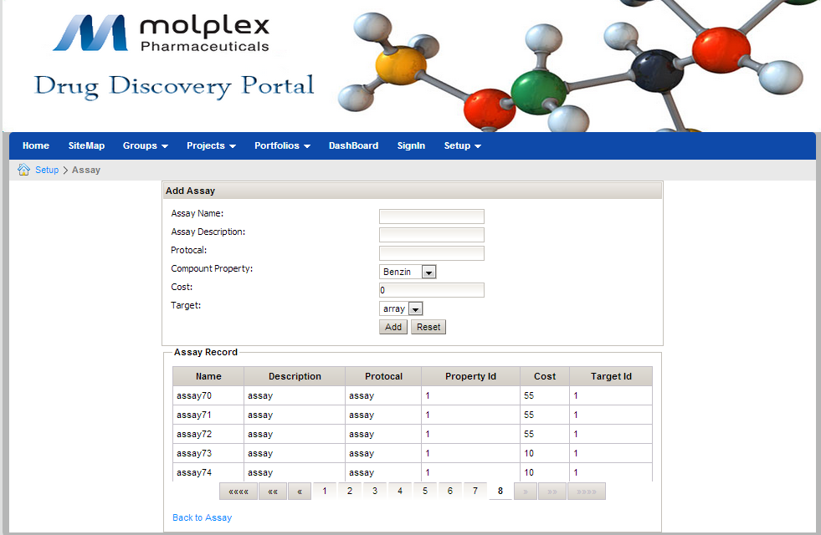

RTP

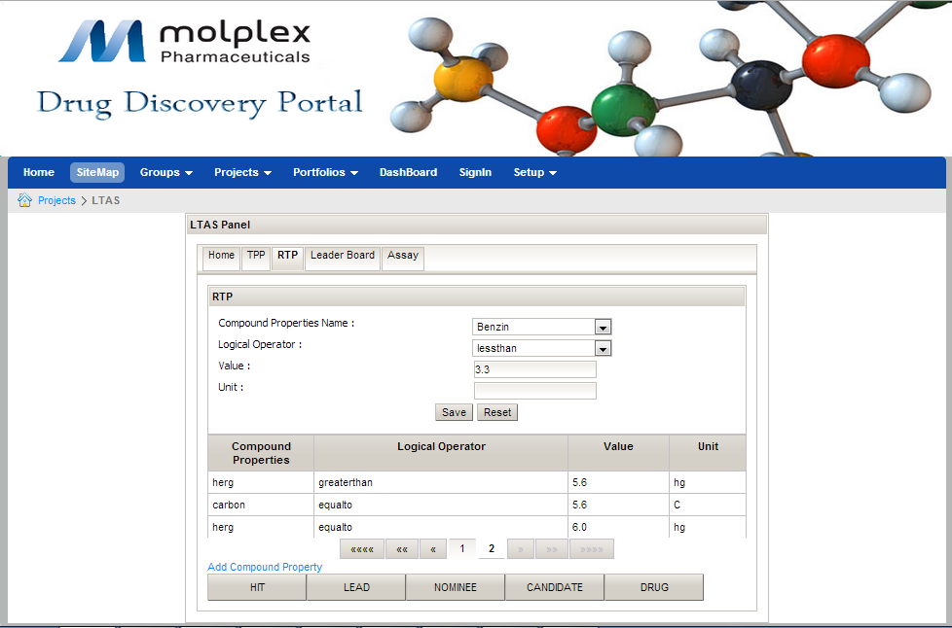

Assay

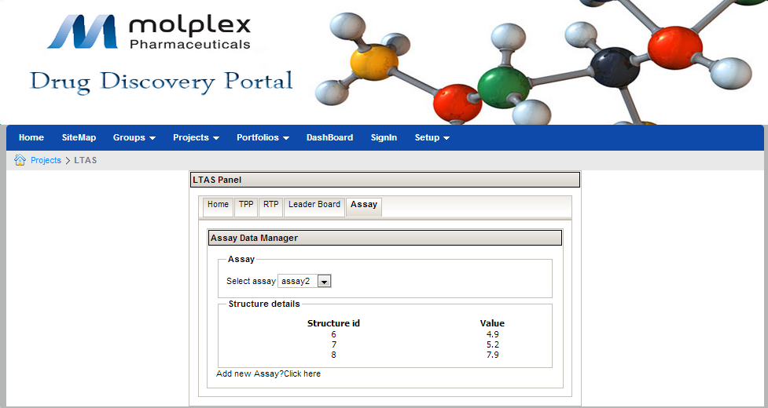

Project

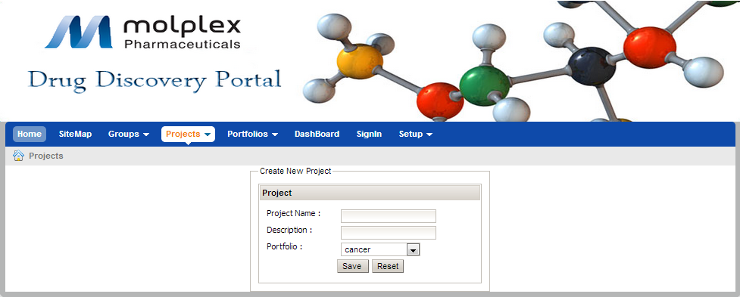

Groups

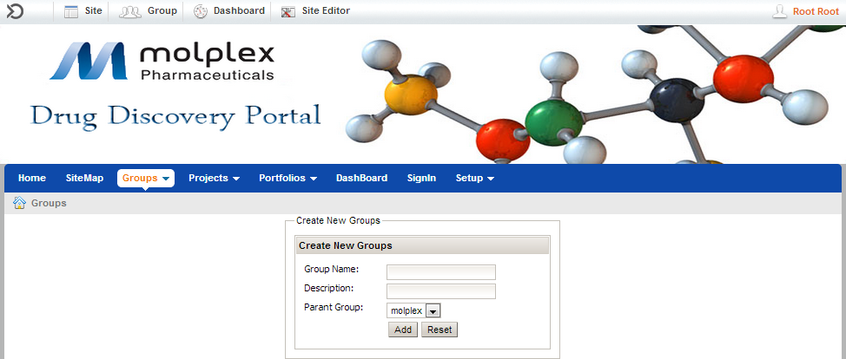

Portfolio

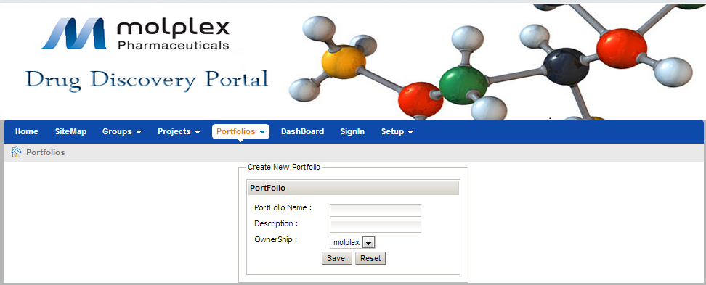

1. RegisterLink & Dash Board Removal:

In order to remove the Register Link ,DashBoard and sitemap we need to copy the web.war file in to the following location.

\GateIn-3.5.0.Final-jbossas7\gatein\gatein.ear

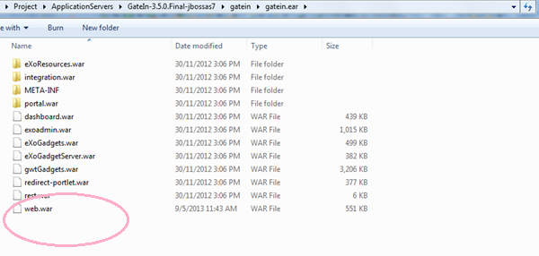

And then need to replace the H2Database because it stores all the information about the Menu need to be display.

So copy the gatin folder from registerLink&dashBoardRemoval folder and paste it into the following location.

\GateIn-3.5.0.Final-jbossas7\standalone\data

